**Year 12 Human Biology**

**Unit 3: Endocrine and Nervous System (5%)**

Name _____________________________

Teacher Mrs Cunningham

**TASK 2**

**TYPE:** Test

**CONTENT:** Endocrine and Nervous System

**Time: 60 mins**

Multiple Choice: 15 marks

Short Answer: 25 marks

Extended Answer: 20 marks

TOTAL 60 MARKS

**Do not turn page until instructed to do so**

**Section A: Multiple Choice (15 Marks)**

Answer all questions by placing an X through the most correct answer on the multiple choice answer sheet.

1. Which of the options below is the first place that is involved in the regulation of Thyroxine?

1. Hypothalamus
2. Anterior pituitary
3. Posterior pituitary
4. Thyroid

2. Which of the options below has a primary role in endocrine function?

1. Pituitary, salivary gland, thyroid gland
2. Pancreas, liver, pituitary gland
3. Islets of langerhans, pituitary gland, adrenal gland
4. Parathyroid glands, adrenal glands, kidney

3. Which of the following is FALSE about the comparison between nervous and hormonal actions of the body?

|  |  |  |
| --- | --- | --- |
|  | **Nervous Action** | **Hormonal action** |
| a) | Impulse electro chemical | Impulse chemical |
| b) | Messenger passed along nerve fibres. | Messenger passed by blood stream |
| c) | Response slow and lasting | response fast and short lasting |
| d) | Not concerned with growth and development | Concerned with growth and development |

4. Ovulation is produced by a rise in:

1. Luteinising hormone and oestrogen.
2. Luteinising hormone and progesterone.
3. Follicle stimulating hormone and oestrogen.
4. Follicle stimulating hormone and progesterone.

5. The target organ for Follicle Stimulating Hormone (FSH) is the:

1. uterine tube.
2. ovary.
3. uterus.
4. vagina.

6. Which one of the following is correct?

|  |  |  |  |
| --- | --- | --- | --- |
|  | Structure | Sympathetic  Activity | Parasympathetic Activity |
| a) | Urinary bladder | Relaxation | Contraction |
| b) | Salivary glands | Increased secretion | Reduced secretion |
| c) | Liver | Increased glucose uptake | Increased release of glucose |
| d) | Bronchioles of the lung | Constriction | Relaxation |

7. Voluntary muscle movement is controlled by:

1. an upper motor neuron in the brainstem and a lower motor neuron in the spinal cord.
2. an upper motor neuron in the cerebrum and a lower motor neuron in the spinal cord.
3. an upper motor neuron in the cerebrum and a lower motor neuron in the dorsal root ganglion.
4. an upper motor neuron in the spinal cord and a lower motor neuron in the skeletal muscle

8. Injury to the hypothalamus may result in all of the following EXCEPT:

1. a loss of temperature control.
2. a production of excessive quantities of urine.
3. loss of awareness of body position.
4. a disrupted menstrual cycle.

9. Which of the following is NOT a function of the cerebrospinal fluid?

1. Transfer of neural messages from one part of the brain to another.
2. Aid removal of metabolic wastes and supply of nutrients to nerve tissue.
3. Suspension of the brain in fluid to reduce pressure on particular points.
4. Protection of the central nervous system from mechanical damage.

10. Which statement about nerve fibres is correct?

1. Fibres that have a larger diameter will conduct impulses slower than those with a smaller diameter.
2. Myelinated fibres conduct impulses slower than unmyelinated nerve impulses.
3. Nodes of Ranvier increase the speed of nerve impulse transmission.
4. All myelinated nerve impulses end on skeletal muscles.

11. The spinal cord has white matter:

1. inside, grey matter outside.
2. outside, grey matter inside and a ventral motor root.
3. outside, grey matter inside and a dorsal motor root.
4. inside, grey matter outside and a ventral motor root.

12. The somatic division belongs to which component of the peripheral nervous system?

1. Afferent
2. Autonomic
3. Efferent
4. Parasympathetic

13. Which of the following is correct?

1. Afferent division carries information into the CNS
2. Efferent division carries information away from the CNS
3. The autonomic division can be responsible for preparing the body for strenuous physical activity
4. All of the above

14. If the sympathetic nerve to the heart was cut, the heart rate would be expected to:

1. increase.
2. decrease.
3. stay the same.
4. increase then decrease.

15. Looking at the picture below, the synapse is labelled:

1. P
2. Q
3. R
4. S

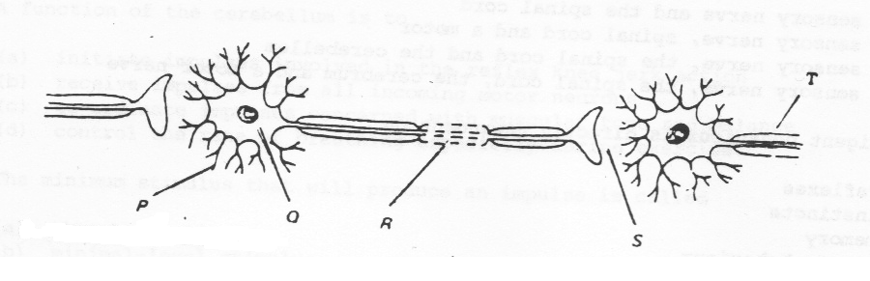

**END OF SECTION A**

**Year 12 Human Biology**

**Unit 3: Endocrine and Nervous System (5%)**

Name _____________________________

Teacher Mrs Cunningham

**TASK 2**

**TYPE:** Test

**CONTENT:** Endocrine and Nervous System

**TOTAL:** /60 MARKS

**Section A: Multiple Choice answer grid 15 marks**

For each question, shade the box to indicate your answer. Use only a blue or black pen to shade the boxes.

For example, if b is your answer: a ⬜ b ⬛ c ⬜ d ⬜

If you make a mistake, place a cross through that square, then shade your new answer. Do

**not** erase or use correction fluid/tape.

X

For example, if b is a mistake and d is your answer: a ⬜ b ⬛ c ⬜ d ⬛

If you then want to use your first answer b, cross out d and then circle b.

X

X

a ⬜ b ⬛ c ⬜ d ⬛

Marks will **not** be deducted for incorrect answers. No marks will be given if more than one answer is completed for any question.

|  |  |
| --- | --- |
| **11** | a ⬜ b ⬜ c ⬜ d ⬜ |
| **12** | a ⬜ b ⬜ c ⬜ d ⬜ |
| **13** | a ⬜ b ⬜ c ⬜ d ⬜ |
| **14** | a ⬜ b ⬜ c ⬜ d ⬜ |
| **15** | a ⬜ b ⬜ c ⬜ d ⬜ |

|  |  |
| --- | --- |
| **1** | a ⬜ b ⬜ c ⬜ d ⬜ |
| **2** | a ⬜ b ⬜ c ⬜ d ⬜ |
| **3** | a ⬜ b ⬜ c ⬜ d ⬜ |
| **4** | a ⬜ b ⬜ c ⬜ d ⬜ |
| **5** | a ⬜ b ⬜ c ⬜ d ⬜ |

|  |  |
| --- | --- |
| **6** | a ⬜ b ⬜ c ⬜ d ⬜ |
| **7** | a ⬜ b ⬜ c ⬜ d ⬜ |
| **8** | a ⬜ b ⬜ c ⬜ d ⬜ |
| **9** | a ⬜ b ⬜ c ⬜ d ⬜ |
| **10** | a ⬜ b ⬜ c ⬜ d ⬜ |

**Section B: Short Answer (25 Marks)**

Answer all questions in the spaces provided.

**Question 16 (6 Marks)**

The diagram below refers to parts (a) through (c) of question 1

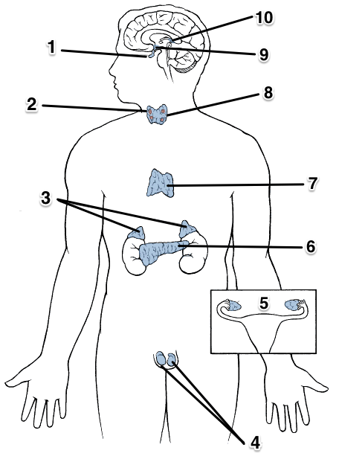

a) Describe how structure 1 will have an effect on the release of hormones from structure 3.

(2 marks)

______________________________________________________________________________

______________________________________________________________________________

______________________________________________________________________________

b) Describe the impact structure 9 has on the endocrine system? Provide an example to support your response. (2 marks)

____________________________________________________________________________________________________________________________________________________________

______________________________________________________________________________

c) If structure 6 was badly damaged, list the hormone(s) which would be affected. (2 marks)

______________________________________________________________________________

**Question 17 (4 Marks)**

A boy was asked to speak, on behalf of the student body, at his year 12 Graduation ceremony. Prior to his speech, he felt extremely nervous.

1. Name the specific division of his nervous system would have contributed to his condition.

(1 mark)

____________________________________________________________________________

1. Name the hormone(s) which would have been involved in this process.

(1 mark)

___________________________________________________________________________

1. Name where this hormone(s) are released from. (1 mark)   
     
   ____________________________________________________________________________
2. Compare the actions of nerves and hormones in regard to the specificity of their actions.

(1 mark)   
___________________________________________________________________________

___________________________________________________________________________

**Question 18 (3 marks)**

The diagram below represents the transmission of a nerve impulse down an axon.



A B C

A B C

A B C

Name and identify the charge at each phase of the nerve impulse represented by the bands labelled A, B, and C. (3 marks)

A ____________________________________________________________________________

______________________________________________________________________________

B ____________________________________________________________________________

______________________________________________________________________________

C ____________________________________________________________________________

______________________________________________________________________________

**Question 19 (4 marks)**

Picture A

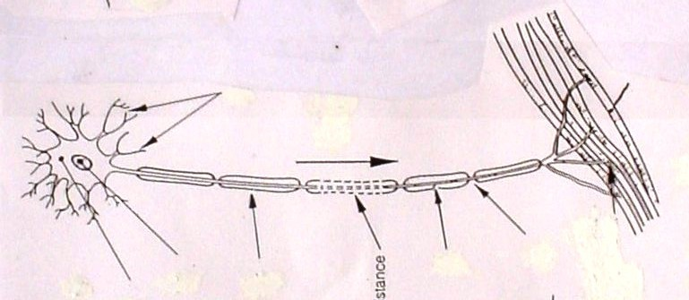

1. Classify the neuron in picture A according to both its structure and function. (2 marks)

Structure

______________________________________________________________________________

Function

______________________________________________________________________________

1. Features on this neuron allow transmission of an can transmit an electrical impulse at a speed of up to 140 metres/second. Explain the reasons why the impulse is able to travel at this speed. (2 marks)

______________________________________________________________________________

______________________________________________________________________________

______________________________________________________________________________

______________________________________________________________________________

______________________________________________________________________________

**Question 20 (8 marks)**

Complete the table below to show the site of production, hormone produced, target organs and effect of the hormones associated with various endocrine glands in the human body.

(8 marks)

|  |  |  |  |
| --- | --- | --- | --- |
| **Production site** | **Hormone produced** | **Target organ/s or Cells** | **Effect** |
| Anterior Pituitary |  | Breast Tissue |  |
|  |  | Liver |  |
|  |  | T-Lymphocytes |  |

**END OF SECTION B**

**Question 21**

**Section C: Extended Answer (20 Marks)**

Answer all parts of ALL questions on the lines provided.

Fiona, a very excitable young girl, was walking along a busy street talking intensely on her mobile phone to her best friend. She was so focused on her conversation that, without thinking, she stepped onto the road and was immediately startled by the screeching of tyres and the blaring sound of a very loud horn. When she realised that she had stepped in front of a car but had not been run over, she felt greatly relieved but noticed that her body had responded in several different ways.

1. Identify three (3) responses that Fiona’s body would automatically demonstrate in her reaction to danger and explain how each is useful in this situation. (6 marks)

Fiona is now afraid and refuses to cross roads without her mother there to hold her hand. The hormone cortisol has been released in her body in response to this stress.

1. Cortisol is a steroid hormone. Describe the mode of action of this hormone on a cell. (3 marks)

**AND**

**Question 22**

The Chemical Weapons Convention was agreed upon in 1997 which prevents the use of chemical weapons to deliberately harm another person. Today, 192 countries are under this treaty which is now international law.

On March 4 2019, former Russian spy Sergei Skripal, his daughter Yulia were exposed to Novichok (a nerve agent) in England. This nerve agent acts to inhibit the enzyme which breaks down neurotransmitters at synapses in the cental and peripheral nervous systems.

1. Describe what happens when a neurotransmitter is not removed from the synapse. (3 marks)
2. Using the somatic nervous system as an example, describe how a nerve impulse travels across a synapse to the effector. (5 marks)
3. Action potentials are described as ‘all or none responses’. However, it is possible for you to detect the difference between a sheet of paper and a brick being dropped on your foot. Explain why. (3 marks)

______________________________________________________________________________

______________________________________________________________________________

______________________________________________________________________________

______________________________________________________________________________

______________________________________________________________________________

______________________________________________________________________________

______________________________________________________________________________

______________________________________________________________________________

______________________________________________________________________________

______________________________________________________________________________

______________________________________________________________________________

______________________________________________________________________________

______________________________________________________________________________

______________________________________________________________________________

______________________________________________________________________________

______________________________________________________________________________

______________________________________________________________________________

______________________________________________________________________________

______________________________________________________________________________

______________________________________________________________________________

______________________________________________________________________________

______________________________________________________________________________

______________________________________________________________________________

______________________________________________________________________________

______________________________________________________________________________

______________________________________________________________________________

______________________________________________________________________________

______________________________________________________________________________

______________________________________________________________________________

______________________________________________________________________________

______________________________________________________________________________

______________________________________________________________________________

______________________________________________________________________________

______________________________________________________________________________

______________________________________________________________________________

______________________________________________________________________________

______________________________________________________________________________

______________________________________________________________________________

______________________________________________________________________________

______________________________________________________________________________

______________________________________________________________________________

______________________________________________________________________________

______________________________________________________________________________

______________________________________________________________________________

______________________________________________________________________________

______________________________________________________________________________

______________________________________________________________________________

______________________________________________________________________________

______________________________________________________________________________

______________________________________________________________________________

______________________________________________________________________________

______________________________________________________________________________

______________________________________________________________________________

______________________________________________________________________________

______________________________________________________________________________

______________________________________________________________________________

______________________________________________________________________________